States of matter

There are 3 common states of matter: solid, liquid and gas.
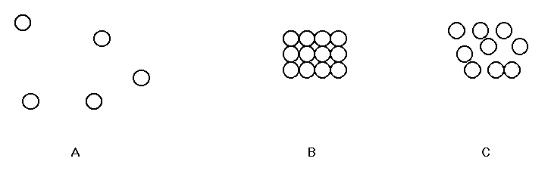
Gas Solid Liquid

The main properties of the three states of matter are set out in the table below.

 | Solid | Liquid | Gas
Distance between particles | Particles touching | Particles touching | Very large distance between particles compared to size of particles.
Motion of particles | Vibrations about a fixed point | Particles can move but travel only short distances before collision | Particles move and travel long distances without collision
Forces between particles | Strong | Similar to in solids | None – the particles are too far apart.

Heat energy is needed to convert a solid to a liquid (melting) and a liquid to a gas (boiling).
The heat energy is needed to overcome the attractions between the particles.

Exercise 15

The melting points and boiling points of elements A – E are given in the table.

Element | Melting point in ºC | Boiling point in ºC | State | Name
A | -210 | -196
B | 327 | 1744
C | 113 | 445
D | -38.9 | 357
E | 3730 | 4830

- Give the state of each element at room temperature (20 ºC).
- The elements are: sulphur, carbon (graphite), nitrogen, mercury and lead.
Write the name of each element in the correct position in the table.

The crystal structure of elements

Elements have three types of crystal structure:

Giant metallic structure – strong metallic bonds between the particles (atoms)
– high melting point
Giant covalent structure – strong covalent bonds between the particles (atoms)
– high melting point
Simple molecular structure – weak forces of attraction between the particles (molecules)
– low melting point

METALS have a giant metallic lattice structure

DIAMOND AND GRAPHITE have a giant covalent structure

NON-METALS have a simple molecular structure

METALS
- Have high melting points and high boiling points.
- Are good conductors of heat and electricity.
- Are described as malleable (can be beaten into sheets) and ductile (can be pulled out into wires).
The properties of metals can be explained by their structure and bonding.

Exercise 16

Metal atoms are packed closely together in a ________ structure. Metals are malleable and ductile because layers of metal atoms can slide past each other without breaking the ________ bond (non-directional forces).

To explain the bonding in metals we imagine that the structure consists of a network lattice of __________ ions which exist in a sea of freely moving outer _________. The strong attraction between the positively charged ______ and the ___________ charged electrons holds the structure together and explains the ________ melting points of metals.

The outer electrons are delocalised which means they are spread over the whole metal structure.
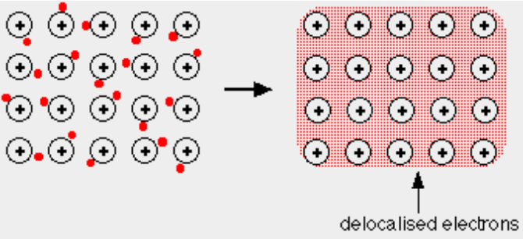

Metals are good conductors of electricity because they have a ______ of moving electrons.

DIAMOND AND GRAPHITE

Diamond
- Has a very high melting point (almost 4000°C).
- Is very hard.
- Doesn't conduct electricity.

Graphite
- Has a very high melting point.
- Has a soft, slippery feel.
- Conducts electricity.

Exercise 17

Diamond and graphite consist of pure _________. They both have a continuous three dimensional structure called _________________ ___________________ lattice.

In diamond, each carbon atom forms __________ covalent bonds with other carbon atoms. It has a ___________ shape around each carbon atom with a bond angle of ______ º. There are no weak forces in this giant ________ structure which is why diamond is very hard and has a very high melting point. Diamond has no free __________ so it does not conduct electricity.

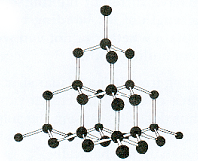
The crystal structure of diamond

In graphite, each carbon atom forms __________ covalent bonds with other carbon atoms. It has a __________ ___________ shape around each carbon atom with a bond angle of _______ º. This produces a flat layer of carbon atoms. Each carbon atom has a spare electron which is _____________ and can move anywhere in the layer. Graphite conducts electricity because it has free ____________. There are only weak van der Waals’ forces between the layers which means the layers can easily _______ across each other making graphite soft and flaky.
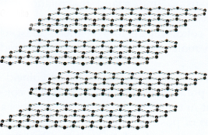

The crystal structure of graphite

NON-METALS
- Have low melting points and low boiling points.
- Do not conduct electricity.
The properties of non-metals can be explained by their structure and bonding.

Exercise 18

Iodine, I₂ has a molecular structure and is composed of __________. The atoms in the molecules are strongly held together by ____________ bonds but there are weak forces of attraction between the ___________. This is why iodine and other non-metals have a low melting point. Non-metals do not conduct electricity because their molecules have no free ________.
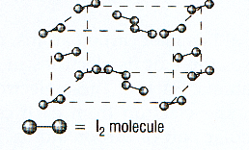

The crystal structure of iodine

Exercise 19

Give the type of bonding and structure, and the properties of sodium chloride, silica, carbon dioxide and water.

Structure | Name and formula | Description of bonding and structure | Melting point  (high or low) | Electrical conductivity
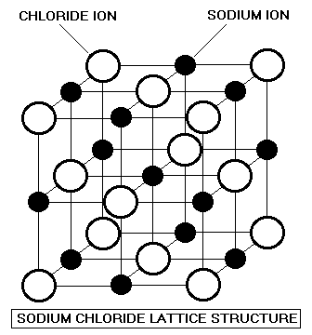 | Sodium chloride  Na⁺Cl⁻
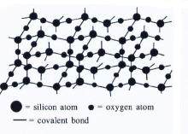 | Silica  SiO₂
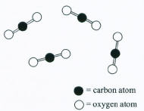 | Carbon dioxide  CO₂
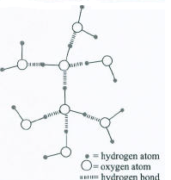 | Water  H₂O



